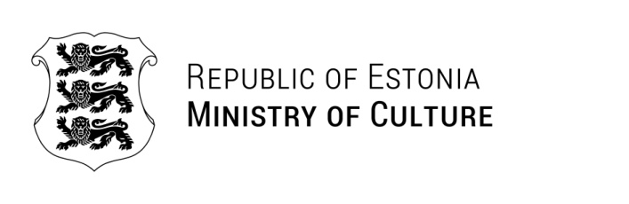

Ms. Hanna Wróblewska | Yours: 19.02.2025 | No
Minister of Culture and National Heritage
Poland | Ours: 10.03.2025 | No 9-8/212-2

Reply to the Invitation to the EU Culture Ministers’ Meeting on 7-8 April 2025 in Warsaw

Dear Ms. Hanna Wróblewska,

Please let me extend my gratitude for your kind invitation to attend the meeting of the EU Culture Ministers in Warsaw in April. Also please allow me to congratulate Poland and wish you the best for the Presidency of the Council of the European Union.

It is now more crucial than ever for the European Union to stand united and to stand with Ukraine, while defending our values and strenghtening European security. Support for young artists and creators, as well as safeguarding tangible and intangible heritage against man-made and natural disasters, that the meeting focuses on, are both of high importance.

Unfortunately, due to previous commitments, I will not be able to attend the meeting in Warsaw. However, I am pleased to announce that Estonia will be represented by the Secretary General of the Ministry of Culture Ms. Kristiina Alliksaar.

Yours sincerely,

Heidy Purga
Minister

Additional recipients: Embassy of Estonia in Warsaw

Ulla Kihva +372 6282357; Ulla.Kihva@kul.ee

